**Карточки-Профессии**

[](http://2.bp.blogspot.com/-Ku4_F7Sc6fk/TVUkK_kfo_I/AAAAAAAAGVw/ysWDNC48Rh4/s1600/%D0%B0%D0%B2%D1%82%D0%BE%D0%BC%D0%B5%D1%85%D0%B0%D0%BD%D0%B8%D0%BA.jpg) [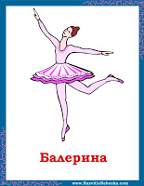](http://2.bp.blogspot.com/-ryew-9WN_zs/TVUkRJ6LhXI/AAAAAAAAGV0/t5YEwAZnKiM/s1600/%D0%B1%D0%B0%D0%BB%D0%B5%D1%80%D0%B8%D0%BD%D0%B0.jpg)

[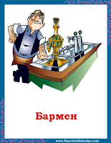](http://2.bp.blogspot.com/-s0TNFSZMz9U/TVUkaa2ZiMI/AAAAAAAAGV4/TlEKYHbT1S0/s1600/%D0%B1%D0%B0%D1%80%D0%BC%D0%B5%D0%BD.jpg) [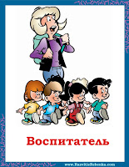](http://3.bp.blogspot.com/-rF8OQYWpKG4/TVUkkiPToDI/AAAAAAAAGV8/EHcy0thUVFY/s1600/%D0%B2%D0%BE%D1%81%D0%BF%D0%B8%D1%82%D0%B0%D1%82%D0%B5%D0%BB%D1%8C.jpg)

[](http://4.bp.blogspot.com/-ZLRrwF-b_q4/TVUktTl7Y6I/AAAAAAAAGWA/fP-9bOiA2p0/s1600/%D0%B2%D1%80%D0%B0%D1%87.jpg) [](http://1.bp.blogspot.com/-JSHuqkmUbqE/TVUk7QKrkFI/AAAAAAAAGWE/_tPiY8uyjus/s1600/%D0%B4%D0%BE%D1%8F%D1%80%D0%BA%D0%B0.jpg)

[](http://3.bp.blogspot.com/-cAsQls3Emk8/TVUlDUHA0fI/AAAAAAAAGWI/iVnBY0jPT7s/s1600/%D0%B6%D1%83%D1%80%D0%BD%D0%B0%D0%BB%D0%B8%D1%81%D1%82.jpg) [](http://3.bp.blogspot.com/-fD_5TJYsVqE/TVUlLoKxwOI/AAAAAAAAGWM/hdyYO2iZ6JI/s1600/%D0%BA%D0%B0%D1%81%D1%81%D0%B8%D1%80.jpg)

[](http://3.bp.blogspot.com/-JvJrSbh-nbc/TVUlTLuV5MI/AAAAAAAAGWQ/m0TCXZpikrc/s1600/%D0%BA%D0%BB%D0%BE%D1%83%D0%BD.jpg) [](http://2.bp.blogspot.com/-rwjKFUxYw2Q/TVUlceu7ywI/AAAAAAAAGWU/0QwIdj4fpQ8/s1600/%D0%BA%D0%BE%D0%BC%D0%B1%D0%B0%D0%B9%D0%BD%D0%B5%D1%80.jpg)

[](http://4.bp.blogspot.com/-RACN2RwVnw8/TVUlkTu_0vI/AAAAAAAAGWY/6bbjjQYCbGI/s1600/%D0%BC%D0%B5%D0%B4%D1%81%D0%B5%D1%81%D1%82%D1%80%D0%B0.jpg) [](http://2.bp.blogspot.com/-ueM4VXl-xoU/TVUlrIwTipI/AAAAAAAAGWc/x_B6bW0sOT0/s1600/%D0%BC%D0%B5%D0%BD%D0%B5%D0%B4%D0%B6%D0%B5%D1%80.jpg)

[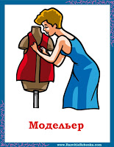](http://1.bp.blogspot.com/-VXABJ_NvIBQ/TVUlyFWHbkI/AAAAAAAAGWg/mOzcM__c2AI/s1600/%D0%BC%D0%BE%D0%B4%D0%B5%D0%BB%D1%8C%D0%B5%D1%80.jpg) [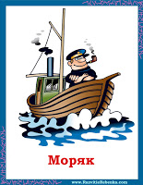](http://3.bp.blogspot.com/-H3rOXQmBJLs/TVUl67Zy30I/AAAAAAAAGWk/RcCZ3gtzvAs/s1600/%D0%BC%D0%BE%D1%80%D1%8F%D0%BA.jpg)

**Карточки с Профессиями для Детей**

[](http://4.bp.blogspot.com/-xTOKB5hEGNs/TVUnHHJXqnI/AAAAAAAAGWo/p6BXWPSedjQ/s1600/%D0%BC%D1%8F%D1%81%D0%BD%D0%B8%D0%BA.jpg) [](http://4.bp.blogspot.com/-dFsJpPtSHe4/TVUnM1__mRI/AAAAAAAAGWs/X8dy-NVDJi0/s1600/%D0%BE%D1%84%D0%B8%D1%86%D0%B8%D0%B0%D0%BD%D1%82.jpg)

[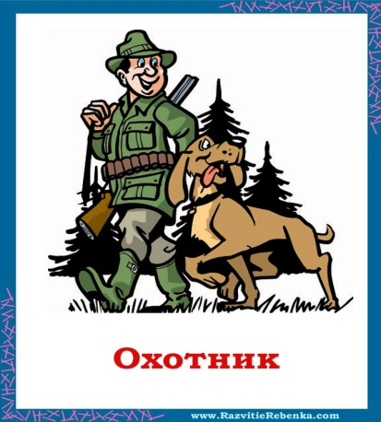](http://1.bp.blogspot.com/-6kDdV2D2BNM/TVUnVq9pS3I/AAAAAAAAGWw/SSCgGZUlPrE/s1600/%D0%BE%D1%85%D0%BE%D1%82%D0%BD%D0%B8%D0%BA.jpg) [](http://2.bp.blogspot.com/-Y3R1_-rEZQ4/TVUndr1KrsI/AAAAAAAAGW0/k-Jbm1-fw98/s1600/%D0%BF%D0%B0%D1%80%D0%B8%D0%BA%D0%BC%D0%B0%D1%85%D0%B5%D1%80.jpg)

[](http://2.bp.blogspot.com/-Ft_jAcvO2O4/TVUnkyiA8zI/AAAAAAAAGW4/oBfkO4EisKw/s1600/%D0%BF%D0%BE%D0%B2%D0%B0%D1%80.jpg) [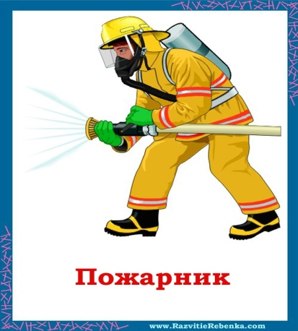](http://1.bp.blogspot.com/-nrWJuPMxhQs/TVUnszJ8M8I/AAAAAAAAGW8/adDY7_GJIAw/s1600/%D0%BF%D0%BE%D0%B6%D0%B0%D1%80%D0%BD%D0%B8%D0%BA.jpg)

[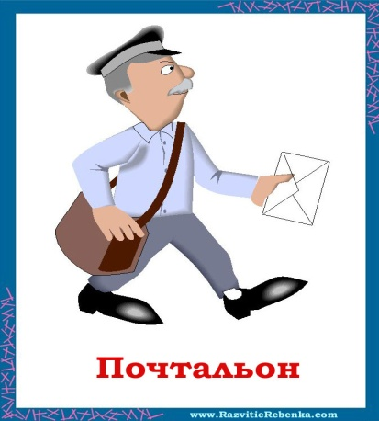](http://1.bp.blogspot.com/-n16IjMOoCjw/TVUnzqL3v-I/AAAAAAAAGXA/SV5F0DgcP4Q/s1600/%D0%BF%D0%BE%D1%87%D1%82%D0%B0%D0%BB%D1%8C%D0%BE%D0%BD.jpg) [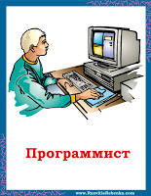](http://4.bp.blogspot.com/-esYEDMEWIis/TVUoAVb3jZI/AAAAAAAAGXE/r0EGavHBdZc/s1600/%D0%BF%D1%80%D0%BE%D0%B3%D1%80%D0%B0%D0%BC%D0%BC%D0%B8%D1%81%D1%82.jpg)

[](http://4.bp.blogspot.com/-Sgjm6Qd4MFg/TVUpdqU0EZI/AAAAAAAAGXI/BxTZXKxcDxU/s1600/%D0%BF%D1%80%D0%BE%D0%B4%D0%B0%D0%B2%D0%B5%D1%86.jpg) [](http://1.bp.blogspot.com/-6pTmWlmBUUk/TVUp3aMgSBI/AAAAAAAAGXM/THegDZhd-vk/s1600/%D1%80%D0%B5%D0%BF%D0%BE%D1%80%D1%82%D1%91%D1%80.jpg)

**Карточки-Профессии**

[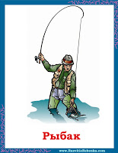](http://2.bp.blogspot.com/-NCLTrCkKaZI/TVUrbYWK5PI/AAAAAAAAGXQ/40SjedEAz4I/s1600/%D1%80%D1%8B%D0%B1%D0%B0%D0%BA.jpg) [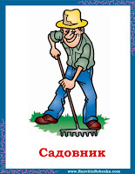](http://1.bp.blogspot.com/-cph_GkS_93g/TVUrmVHJC-I/AAAAAAAAGXU/E0FZMgxpmHg/s1600/%D1%81%D0%B0%D0%B4%D0%BE%D0%B2%D0%BD%D0%B8%D0%BA.jpg)

[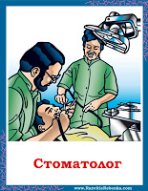](http://3.bp.blogspot.com/-Y2les6ZwOBA/TVUr0TAgrII/AAAAAAAAGXY/NggyiWPfSSE/s1600/%D1%81%D1%82%D0%BE%D0%BC%D0%B0%D1%82%D0%BE%D0%BB%D0%BE%D0%B3.jpg) [](http://4.bp.blogspot.com/-F2TiPa6VuxQ/TVUsA8UthuI/AAAAAAAAGXc/cLwPoEZ56KQ/s1600/%D1%81%D1%82%D1%80%D0%BE%D0%B8%D1%82%D0%B5%D0%BB%D1%8C.jpg)

[](http://4.bp.blogspot.com/-kr5uvNQJPiE/TVUsJ8VlomI/AAAAAAAAGXg/LSCVP9uXz3s/s1600/%D1%81%D1%83%D0%B4%D1%8C%D1%8F.jpg) [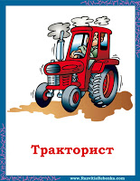](http://1.bp.blogspot.com/-V-GYWC75qDs/TVUsUi75xrI/AAAAAAAAGXk/zATIG7kh-ZQ/s1600/%D1%82%D1%80%D0%B0%D0%BA%D1%82%D0%BE%D1%80%D0%B8%D1%81%D1%82.jpg)

[](http://2.bp.blogspot.com/--TY3Is45MN8/TVUsgFdRImI/AAAAAAAAGXo/TL_ulcZW92k/s1600/%D1%83%D0%BA%D1%80%D0%BE%D1%82%D0%B8%D1%82%D0%B5%D0%BB%D1%8C.jpg) [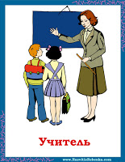](http://3.bp.blogspot.com/-5rRzkENhQIQ/TVUsvY0dtjI/AAAAAAAAGXs/J67dH4Rpf1U/s1600/%D1%83%D1%87%D0%B8%D1%82%D0%B5%D0%BB%D1%8C.jpg)

[](http://4.bp.blogspot.com/-HHX9BYRYyD4/TVUtAOwsGfI/AAAAAAAAGXw/SFmE5HSD0ac/s1600/%D1%84%D0%B5%D1%80%D0%BC%D0%B5%D1%80.jpg) [](http://4.bp.blogspot.com/-5wkJ0zidUMo/TVUtLUB4f3I/AAAAAAAAGX0/T0IguYfw3z0/s1600/%D1%84%D0%BE%D1%82%D0%BE%D0%B3%D1%80%D0%B0%D1%84.jpg)

[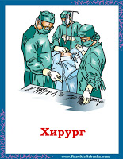](http://2.bp.blogspot.com/-QbnQP4valY0/TVUtqKm9GWI/AAAAAAAAGX4/c_d_i9Plpv4/s1600/%D1%85%D0%B8%D1%80%D1%83%D1%80%D0%B3.jpg) [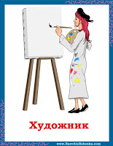](http://4.bp.blogspot.com/-JaIctCy7xv0/TVUt0JYl6yI/AAAAAAAAGX8/LLxZQMrNm8c/s1600/%D1%85%D1%83%D0%B4%D0%BE%D0%B6%D0%BD%D0%B8%D0%BA.jpg)

[](http://2.bp.blogspot.com/-GUdq2n4VKto/TVUuCuYxh3I/AAAAAAAAGYA/GWjo-Gv6-G8/s1600/%D1%88%D0%B2%D0%B5%D1%8F.jpg) [](http://1.bp.blogspot.com/--_RzXZKkhvc/ULnq1w98akI/AAAAAAAAP7k/y3hxYb4HhMI/s1600/%D0%9C%D0%B0%D1%88%D0%B8%D0%BD%D0%B8%D1%81%D1%82.jpg)

**Профессии карточки для детей**

[](http://1.bp.blogspot.com/-9Ttp4JwML94/UUnh18Z0jtI/AAAAAAAARx8/kW3HG06yRR4/s1600/%D0%B2%D0%BE%D0%B4%D0%B8%D1%82%D0%B5%D0%BB%D1%8C.jpg) [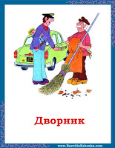](http://4.bp.blogspot.com/-CjsWkX6JyvM/UUnh3YXnVkI/AAAAAAAARyE/cf-vMRTCZZE/s1600/%D0%B4%D0%B2%D0%BE%D1%80%D0%BD%D0%B8%D0%BA.jpg)

[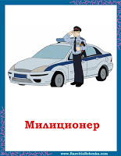](http://3.bp.blogspot.com/-YO4qUau7wfw/UUnh41AW97I/AAAAAAAARyM/xpE9YcD9ZxY/s1600/%D0%BC%D0%B8%D0%BB%D0%B8%D1%86%D0%B8%D0%BE%D0%BD%D0%B5%D1%80.jpg) [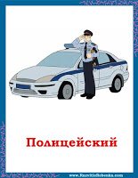](http://4.bp.blogspot.com/-b0R5_BCnDaY/UUnh62EczFI/AAAAAAAARyU/Q6qEY1-ntpk/s1600/%D0%BF%D0%BE%D0%BB%D0%B8%D1%86%D0%B5%D0%B9%D1%81%D0%BA%D0%B8%D0%B9.jpg)

[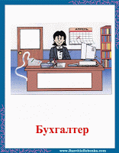](http://2.bp.blogspot.com/-owQ-0VXEXqg/UnZj7vcvATI/AAAAAAAAUSU/tlj5h3kdP3M/s1600/%D0%B1%D1%83%D1%85%D0%B3%D0%B0%D0%BB%D1%82%D0%B5%D1%80.gif) [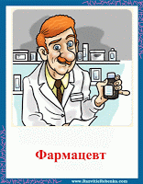](http://3.bp.blogspot.com/-t06GtziWUOo/UnZj8SJmDZI/AAAAAAAAUSc/T9H1gvpxq0o/s1600/%D1%84%D0%B0%D1%80%D0%BC%D0%B0%D1%86%D0%B5%D0%B2%D1%822.gif)

[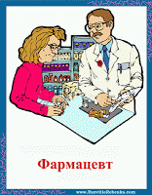](http://1.bp.blogspot.com/-2tLu-_N8yj0/UnZj9KRRHdI/AAAAAAAAUSk/KwDwM3ecLUc/s1600/%D1%84%D0%B0%D1%80%D0%BC%D0%B0%D1%86%D0%B5%D0%B2%D1%82.gif)

**Карточки профессии**

[](http://3.bp.blogspot.com/-v0B3lpyAT8o/UnZlAXlXgUI/AAAAAAAAUTA/c5RlcF176mo/s1600/%D0%BB%D1%91%D1%82%D1%87%D0%B8%D0%BA.gif) [](http://1.bp.blogspot.com/-f2-zq4J-ORU/UnZlBbxHXxI/AAAAAAAAUTI/AqPYUncanvw/s1600/%D1%81%D1%82%D1%8E%D0%B0%D1%80%D0%B4%D0%B5%D1%81%D1%81%D0%B0.gif)

[](http://3.bp.blogspot.com/-57Up0ETy76g/Uqn13bNG21I/AAAAAAAAUu4/5ZuMWPY-zyM/s1600/%D0%93%D1%80%D1%83%D0%B7%D1%87%D0%B8%D0%BA.gif) [](http://4.bp.blogspot.com/-dy-tI5D-B0s/Uqn14C7oitI/AAAAAAAAUvA/evPwQQntIGA/s1600/%D0%B4%D0%B8%D1%80%D0%B5%D0%BA%D1%82%D0%BE%D1%80.gif)

[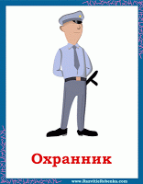](http://3.bp.blogspot.com/-T7A6pJWdVbo/Uqn14t987YI/AAAAAAAAUvE/0ibRrsbhgk0/s1600/%D0%BE%D1%85%D1%80%D0%B0%D0%BD%D0%BD%D0%B8%D0%BA.gif) [](http://4.bp.blogspot.com/-i1mtALLtya4/Uqn16HT9V6I/AAAAAAAAUvQ/U5O8qBzX0xk/s1600/%D0%BF%D1%80%D0%BE%D0%B4%D0%B0%D0%B2%D0%B5%D1%862.gif)

[](http://2.bp.blogspot.com/-P3N3mTZu3uo/Uqn16e7CKcI/AAAAAAAAUvU/tV8OqtFv1fk/s1600/%D0%BF%D1%80%D0%BE%D0%B4%D0%B0%D0%B2%D0%B5%D1%86.gif) [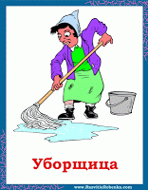](http://2.bp.blogspot.com/-gnk5RyReYgo/Uqn166stRKI/AAAAAAAAUvg/fI6g59fOb9w/s1600/%D1%83%D0%B1%D0%BE%D1%80%D1%89%D0%B8%D1%86%D0%B0.gif)

 